The power of the Distributed MajorBBS Architecture
White Paper on Vircom’s DMA

- Are you ready to add more lines, but your BBS’s performance is already suffering from the load of the current lines and modules?

- Are you postponing your Worldgroup upgrade, because its 16Megs RAM constraint will force you to disable useful modules currently running under MajorBBS?

- Are you refraining from purchasing new modules in fear they will conflict with others and crash your BBS?

- Are you ready to expand to multiple cities, yet you would like to capitalize on your investment in your current technology?

If you answered yes to any of the above questions, then Vircom’s MajorTCP/IP product has an answer for you: its Distributed MajorBBS Architecture.

In essence, this option allows you to set up children systems running your MajorBBS/Worldgroup modules. The communication between the master and its sub-BBSes (DMA servers) is so transparent to the users, they won’t know a second computer is involved altogether! They can still use all the global commands of the parent BBS as if the module was still running there, providing the module doesn’t disable the global commands. Look at this basic application of the power of MajorTCP/IP’s DMA:

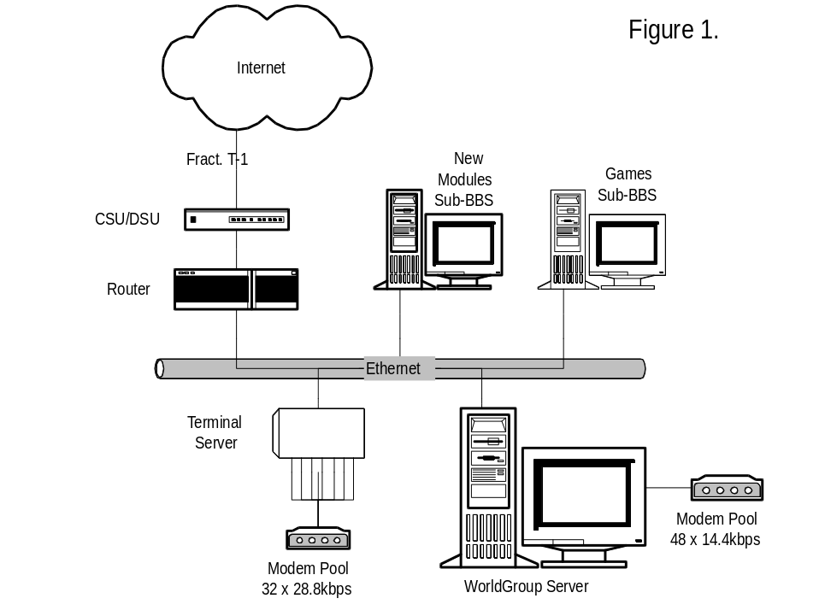
The operators of this entertainment system have installed 32 fast modems on a terminal server to reduce the performance impact on their Worldgroup server, but that was not enough; the response-time was still not smooth enough to their liking. They have then setup a second Worldgroup server, and moved their big modules (such as Trade Wars, Tele-Arena & MajorMUD) to it. This has freed quite a bit of RAM and reduced the CPU drain on their main Worldgroup server, that now focuses on servicing callers. They now have a decent response-time. Their short term expansion revolves around the installation of a hot new game, still in beta-testing. They decide to setup a second DMA server to install the game there, so that if it crashes, all the other services will remain functional.

The Distributed MajorBBS Architecture (DMA) is in fact so powerful that, in its own right, it opens a new on-line market! Let’s see just how powerful and innovative it can get.

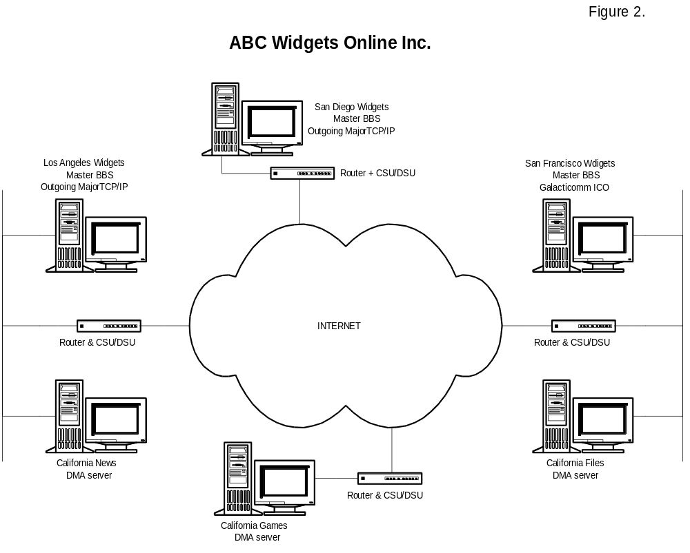
Note: The above example is fictitious and is not intended to represent any existing setup.

The ABC Widgets Online Inc. (AWO) network is composed of three points of presence: San Francisco, Los Angeles & San Diego, each running an average of 60 lines. The company has sub-contracted the services of California Games Inc., based in Anaheim, which specializes in games deserving a total of 6 MajorBBS & Worldgroup servers (3 of which belong to AWO). AWO has also purchased two high-end servers, equipped with large disk arrays; one as the San Diego news (NNTP)/forums server and the other, also equipped with 2 CD-ROM’s jukeboxes, running from San Francisco, and acting as file library server. They have both been setup as Sub-BBS’es, and are deserving the users of the three master systems.
As you can see from the above example of California Games Inc., a new class of systems has been created through Vircom’s Distributed MajorBBS Architecture: the on-line service supplier. By using the Internet & MajorTCP/IP, it becomes possible to create a very specialized system meant to have other MajorBBS/Worldgroup sysops as clients, not end-users!

Just imagine the thrill of playing in a game of Trade Wars that could have hundreds, and maybe even thousands, of players! It’s no secret that running an Unix Usenet news server is a time (After all, Unices are known to be user-friendly, right?) and resources hog. Why not buy a expensive hardware only once, and run it within the comfortable environment of MajorBBS? Vircom’s Distributed MajorBBS Architecture opens a whole new dimension, that can smaller sites to offer services that rivals with the biggest names in the on-line world (Compuservce, Genie, AOL, etc.).

Galacticomm, recognizing the power of the Distributed MajorBBS Architecture, and Vircom have signed an alliance to promote it together. This agreement offers a legal solution now to a growing problem. But there are limitations to what DMA currently can do. You are still limited by the number of users a single machine can handle. You can’t have global commands (like broadcasts) affect more than one master system. You can maintain the same UserID record on more than one master system. Vircom wants to give the Worldgroup/MajorBBS community the power it needs to continue to grow...

Goals of DMA v3.0

- Database Replication Server: This will allow master systems to replicate databases such as the users databases (with their accounting information). The objective is to allow users to login from any of the replicated master systems without being to tell them apart. (Presuming they are configured identically.)

- Event Control Link: The propagation of events such as invoked global commands, shutdown messages, etc. between either two master systems or a master system and a DMA v3.0 server. This option will allow not only the databases to work as one, but also the online processes.

- Queries Protocol: The queries protocol will allow the transfer of information with either a DMA v3.0 server or another master system. This is a crucial component of this new release. The users won’t use this protocol directly.

Licensing & Costs

Vircom and Galacticomm have recently announced a strategic alliance to promote Vircom’s Distributed MajorBBS Architecture. This agreement allows DMA customers the right to copy their license of the MajorBBS/Worldgroup server and all its six packs for use as one DMA server (sub-BBS). The DMA server will be restricted to one LAN channel, for SysOp maintenance, and the incoming DMA channels; no other (hardware) channel of any kind may be defined. The spirit of the agreement is that all incoming sessions to the DMA server must go through a legal MajorBBS/Worldgroup server master system. Version 2.1 and above of Vircom’s DMA server enforce this restriction. The products necessary to create a DMA setup are as follow:

- MajorTCP/IP Outgoing: Priced at $500 USD, this version would run on a master system and only permits TCP/IP traffic originating from this system. The product supports up to 64 (outgoing) TCP/IP sessions.

- MajorTCP/IP Combo: Priced at $700 USD, this version has all the features of the above version, but also sports all “Internet servers” software, such as World Wide Web, Finger, SMTP (Mail), Incoming Telnets & Rlogins and NNTP (when available). The product supports up to 255 TCP/IP sessions.

- DMA Server: Priced at $700 USD, the DMA server includes Galaticomm’s “right to copy” license, with the restrictions as described above. ICO customers purchasing the DMA server receive a single license of the DMA client for ICO. The DMA server allows for 255 TCP/IP sessions and can run most “Internet servers” of MajorTCP/IP (WWW, Finger, SMTP and NNTP, when available).

- MajorTCP/IP “Unlimited”: This $500 USD upgrade allows any one of the above modules to support a maximum of 1024 TCP/IP sessions.

- DMA Client for ICO: This $250 USD product allows ICO customers to connect to DMA servers in the same fashion as MajorTCP/IP customers. A single license of this product comes with the purchase of the DMA server by ICO customers; additional licenses must be purchased to run on other ICO master systems.

For budgetting purposes, let’s look at the bill for both of the above example:

Figure 1.

Product Name | Cost
Worldgroup server & 16 six packs (104 users) | varies
MajorTCP/IP Combo (master system)* | $ 700.00
2x DMA Server | $ 1,400.00
Total: | $ 2,100.00

* Galacticomm ICO could be used instead.

Figure 2.

Product Name | Cost
3x Worldgroup server & 9 six packs (62 users each) | varies
2x MajorTCP/IP Outgoing only (master systems)* | $ 1,000.00
1x Galacticomm ICO* | varies
2x DMA Server | $ 2,100.00
1x DMA client for ICO* | $ 250.00
Total: | $ 3,350.00

* Presumes client had an ICO license.

October 6, ‘95.

Note: At the time of this writing, Vircom’s NNTP server is still under development.

MajorTCP/IP, DMA Server & DMA Client for ICO are products of Vircom inc. ICO is a product of Galacticomm.

